Ex no: 1 | Decision Making Statements
Date : | Decision Making Statements

Question
Write a Python program to construct the following pattern, using a nested loop number.

Aim
To Write a Python program to construct the following pattern, using a nested loop number.

Algorithm
Step1.Get a value for n.
Step 2. Set for ro run until n value
Step 3. Set second for loop inner loop to run n+1 times
Step 4. Print the value of i

Code
for i in range(1,8):
for j in range(1,i+1):
print(i,end =" ")
print()

Output
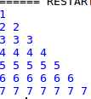

Result

Thus To Write a Python program to construct the following pattern, using a nested loop number.
has been successfully developed and the output was verified.

Ex no: 2 | Decision Making Statements
Date : | Decision Making Statements

Question
Develop a python program to display the Previous Greatest Element (PGE) for every element entered by
the user until the limit. To find the Previous greatest Element compare it with the next element. Elements
for which no greater element exist, consider next greater element as -1.

Aim
To Develop a python program to display the Previous Greatest Element (PGE) for every element entered

Algorithm
Step1.Set first=0 and neg =-1
Step 2. Get the value for b
Step 3. Set the for loop range of b
Step 4. Get the value for a
Step 5. Set conmdition if a > first
Step 6.Print neg
Step 7. Otherwise print first
Step 8. Set first =0

Code
first=0
b=eval(input("Enter the limit"))
neg=-1
for i in range(b):
a=eval(input("Enter the Number"))
if (a>first):
print(neg)
else :
print(first)
first=a

Output

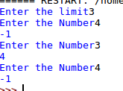

Result
Thus To Develop a python program to display the Previous Greatest Element (PGE) for every element entered has been successfully developed and the output was verified.

Ex no: 3 | String Operations
Date : | String Operations

Question
Develop a python code to get the string from the user and check whether it is palindrome or
not. If its palindrome display the message as ”Correct” else print the number of alphabets,
digits, special character

Aim
To Develop a python code to get the string from the user and check whether it is palindrome or
Not

Algorithm
Step1.Get the string
Step 2.Check if string ==string[::-1]
Step 3. Then display the string is palindrome
Step 4. Otherwise set c,c1,c2,c3,c4=0
Step 5. Set for loop range of string lenght
Step 6.check islower and increase the count1
Step 7. check issupper() the increase the count2
Step 8. check isnumeric then increase the count3
Step 9.Otheerwise increase the count4
Step 10.print count1,count2,count3,count4

Code
string=input("Enter string:")
if(string==string[::-1]):
print("The string is a palindrome")
else:
count1=0
count2=0
count3=0
count4=0
for i in string:
if(i.islower()):
count1=count1+1
elif(i.isupper()):
count2=count2+1
elif(i.isnumeric()):
count3=count3+1
else:
count4=count4+1
print("The number of lowercase characters is:")
print(count1)
print("The number of uppercase characters is:")
print(count2)
print("The number of digit characters is:")
print(count3)
print("The number of special char is:")
print(count4)

Output

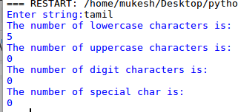

Result
Thus To Develop a python code to get the string from the user and check whether it is palindrome or not has been successfully developed and the output was verified.

Ex no: 4 | String Operations
Date : | String Operations

Question
Write a python program to count repeated characters in a string and also reverse it.

Aim
To Write a python program to count repeated characters in a string and also reverse it.

Algorithm
Step1.Get the string one
Step 2. Set sring=string.split(“ ”)
Step 3. Change the string into list()
Step 4. Set the for loop in range of string lenght
Step 5. Check the condition string1not in list string
Step 6.Then append it into another list
Step 7. Then sort the list
Step 8. print the list

Code
string=input("enter the stringto remove duplicate ")
string=string.split(" ")
string=list(string)
li=[]
for i in range(len(string)):
if (string[i] not in li):
li.append(string[i])
p=sorted(li)
print("Sorted order is .....")
print(p)

Output

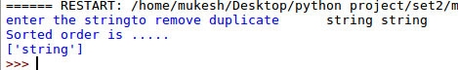

Result
Thus To Write a python program to count repeated characters in a string and also reverse it.
been successfully developed and the output was verified.

Ex no: 5 | Programming with List Concept
Date : | Programming with List Concept

Question
A website requires the users to input username and password to register. Develop a program to check
the validity of password input by users. Following are the criteria for checking the password:
1. At least 1 letter between [a-z]
2. At least 1 number between [0-9]
3. At least 1 letter between [A-Z]
4. At least 1 character from [$#@]
5. Minimum length of transaction password: 6
6. Maximum length of transaction password: 12

Aim
To Construct A website requires the users to input username and password to register.

Algorithm
Step1.Set c1,c2,c3,c4=0
Step 2. Get the n value
Step 3.Set the loop to range of lenght of pass
Step 4. Check all condition isdight,isupper,islower increase the c corresponding
Step 5. Check the condition c1,c2,c3,c4>0
Step 5.Print valid
Step 6.Otherwise print invalid

Code
c1=0
c2=0
c3=0
c4=0
n=input("Enter the password")
if len(n)>=6 or len(n)<=25:
for i in range(len(n)):
if (n[i].isdigit()==True):
c1=c1+1
elif (n[i].isupper()==True):
c2=c2+1
elif (n[i].islower()==True):
c3=c3+1
elif n[i]=='$' or n[i]=='@' or n[i]=='#' :
c4=c4+1
if c1>0 and c2>0 and c3>0 and c4>0:
print("Valid password")
else:
print("invalid...try again")

Output

Result

Thus To Construct A website requires the users to input username and password to register.
has been successfully developed and the output was verified.
Ex no: 6 | Programming with List Concept
Date : | Programming with List Concept

Question
Create Lists named District_1, District_2, District_3, District_4, District_5
Example:District_1 =[‘Eastkhasihills’, ‘Assam&meghalaya’, 5790.7, 4277.2, 35]
a) Display
a. The list District_2
b. The sub division of District 1 and 2.
c. The Name of the District with variance 19.
d. Display District_5 * 2
e. Display District_3 + District_4
b) Display (with Conditions)
a. Display “Yes” if normal value in List District_1 is 4277.2 else “No”
b. Display “Yes” and value if variance is 26 in District_2 else “No”
c) Delete
a. The element at the index 0 in District_3.
b. The Name of the district in District_5.
d) Update
a. The list District_2[0] = ‘Nilgris’ and display the updated list
b. The Variance in District_4 as 68 and display the updated list
e) Length
a. Find the length of the lists District_2 and District_5
f) List
a. Convert District_1[0] into a list
g) All
a. Check the lists District_1 and District_2 whether they are true or not.
h) Any
a. Check the lists District_4 and District_5 whether they are true or not.i)
Copy
a. Copy the elements of District_3 into List_1 and display the new list.
b. Copy the elements of District_5 into List_2 and display the new list.

Aim
To Develop a python program to solve the following operations with the information given above.

Algorithm
Step1.Declare a=[['East Khasi','Lower Dibang valley','East Ssiang','Chiranjg','kokrajhar']]
Step 2. Declare b=[['Assam and Ghalaya','Arnacahl Pradesh','Arnacahl Pradesh','assam and maghalaya','assam and maghalkaya']] c=[[5790.7,3581,3309,3219,3020]] d=[[4277.2,888.4,2661.4,2048.0,2544.1]] e=[[35,303,24,57,19]]
Step 3. print(a[0][1],',',b[0][1],',',b[0][1],',',d[0][1],',',e[0][1])
print(b[0][0],b[0][1])
print(a[0][4])
print(5* a[0][4])
print(a[0][2]+a[0][3])
Step 4. if (d[0][0]==4277.2):
print("YES normal value in List District_1 is 4277.2")
Otherwise
print("NO normal value in List District_1 is 4277.2 ")
if (e[0][1]==26):
print("YES variance is 26 in District_2")
Otherwise
print("no variance is 26 in District_2")
Step 5. a[0].remove('East Ssiang')
print(a[0][3],b[0][4],c[0][4],d[0][4],e[0][4])
Step 6.a[0][1]='Nilgris'
e[0][4]=68
Step 7. print("The length of dist 1")
print(len(a[0]))
print("The lenght of dist 5")
print(len(d[0]))
print(a[0])
Step 8. print('district 1',all(a[0][0]))
print('district 2',all(a[0][1]))
print('district 4',any(a[0][2]))
print('district 5',all(a[0][3]))
Step 9. list1=[a[0][2],b[0][2],c[0][2],d[0][2],e[0][2]]
list3=list1
list2=[a[0][3],b[0][4],c[0][4],d[0][4],e[0][4]]
list4=list2
print(list3)
print(list4)

Code
list2=[]
a=[['East Khasi','Lower Dibang valley','East Ssiang','Chiranjg','kokrajhar']]
b=[['Assam and Ghalaya','Arnacahl Pradesh','Arnacahl Pradesh','assam and maghalaya','assam and maghalkaya']]
c=[[5790.7,3581,3309,3219,3020]]
d=[[4277.2,888.4,2661.4,2048.0,2544.1]]
e=[[35,303,24,57,19]]
print(a[0][1],',',b[0][1],',',b[0][1],',',d[0][1],',',e[0][1])
print(b[0][0],b[0][1])
print(a[0][4])
print(5* a[0][4])
print(a[0][2]+a[0][3])

#Answer B
if (d[0][0]==4277.2):
print("YES normal value in List District_1 is 4277.2")
else:
print("NO normal value in List District_1 is 4277.2 ")
if (e[0][1]==26):
print("YES variance is 26 in District_2")
else:
print("no variance is 26 in District_2")

#Answer c
a[0].remove('East Ssiang')
print(a[0][3],b[0][4],c[0][4],d[0][4],e[0][4])

#answer d
a[0][1]='Nilgris'
e[0][4]=68

#answer e
print("The length of dist 1")
print(len(a[0]))
print("The lenght of dist 5")
print(len(d[0]))
print(a[0])

#answer g and h
print('district 1',all(a[0][0]))
print('district 2',all(a[0][1]))
print('district 4',any(a[0][2]))
print('district 5',all(a[0][3]))

#answer i
list1=[a[0][2],b[0][2],c[0][2],d[0][2],e[0][2]]
list3=list1
list2=[a[0][3],b[0][4],c[0][4],d[0][4],e[0][4]]
list4=list2
print(list3)
print(list4)

Output

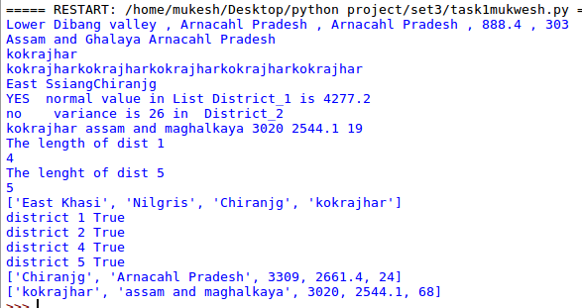

Result
To Construct A website requires the users to input username and password to register.
has been successfully developed and the output was verified.

Ex no: 7 | Programming With Advance List concept
Date : | Programming With Advance List concept

Question
Write a Python program to check whether a given number is an ugly number or not from the range of
1 to 10.The number must be inputted by the user. Append each of the ugly numbers into the list and
display it

Aim
To Write a Python program to check whether a given number is an ugly number or not from the range

Algorithm
Step1.Declare the list1 ,list2
Step 2.Set the for loop range 11
Step 3. Get the x
Step 4. Chack if(x%2 or 3 or 5)
Step 5. Thn append it on x
Step 6.Otherwise append it on another list
Step 7. print li or li2

Code
li=[]
li1=[]
for i in range (1,11):
x=eval(input("Enter The nUmber"))
if(x%2==0 or x % 3 ==0 or x%5 ==0):
li.append(x)
else:
li1.append(x)
print("Ugly number is",li)
print("Non Ugly number is",li1)

Output
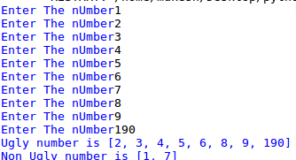

Result
Thus To Write a Python program to check whether a given number is an ugly number or not from the range has been successfully developed and the output was verified.

Ex no: 8 | Programming With Advance List concept
Date : | Programming With Advance List concept

Question
Develop a python code to for Menu driven operation .If the user enter choice is ‘A’ it must displays the.prime number series from range 1 to 20 else if the choice is ‘B’ it must display the multiples of 5.Use.List concept to implement option ‘B’ using list comprehension.

Aim
To Develop a python code to for Menu driven operation .If the user enter choice is ‘A’ it must displays the prime number series B for multiples of 5

Algorithm
Step1.Declare the list li,l1
Step 2. Get the choice ‘A’ or ‘B’
Step 3.If the choice is ‘A’
Step 4. print the prime numbers in range 2 to 20
Step 5. If the choice is ‘B’
Step 6. print the tables of 5 in range to 20

Code
li=[]
l1=[]
input_1=input("Enter the A or B ")
if input_1=="A":
for i in range(2,20):
for num2 in range(2,i):
if(i%num2==0):
break
else:
li.append(i)
print(li)
elif(input_1=="B"):
l1=[i*5 for i in range(0,20)]
print(l1)
else:
print("Please enter A or B")
Output
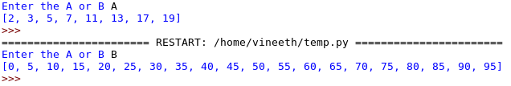

Result
Thus To Develop a python code to for Menu driven operation .If the user enter choice is ‘A’ it must displays the prime number series B for multiples of 5 has been successfully developed and the output was verified.

Ex no: 9 | Tuple Operations On Python Programming
Date : | Tuple Operations On Python Programming

Question
Develop a python program to add 2 values into an existing tuple named as tuple_1 which has 2
elements. Create two more tuples named as tuple_2 and tuple_3 having same size of tuple_1.
a) Convert all these 3 tuples as nested tuple in a list.
b) Sort all the elements in each tuple.
c) Map the tuples in such a way that 0 th index of all tuples, 1 st index of all tuples, 2 nd index of all
tuples and 3 rd index of all tuples.
d) Find the maximum and minimum value of each tuple.

Aim
To Develop a python program to add 2 values into an existing tuple named as tuple_1 which has 2
elements.

Algorithm
Step1.Get a value for n.
Step 2. Set for ro run until n value
Step 3. Append it on the tupple
Step 4. Print the value of i
Step 5.Set for ro run until lenght of tupple
Step 6. Append it on the tupple2
Step 7. Set for ro run until lenght of tupple1
Step 8. Append it on the tupple3
Step 9. Sort all the tupple value and print

Code
tuple1=[ ]
tuple2=[ ]
tuple3=[ ]
c=[ ]
d=[ ]
e=[ ]
n=eval(input("Enter the n value "))
for i in range (n):
tuple1.append(eval(input("Enter the element for tuple 1 ")))
for i in range (len(tuple1)):
tuple2.append(eval(input("Enter the element for tuple2 ")))
for i in range (len(tuple2)):
tuple3.append(eval(input("Enter the element for tuple 3 ")))
print('Sorted tuples is........ ')
tuple1.sort()
c=tuple1
tuple2.sort()
d=tuple2
tuple3.sort()
e=tuple3
print(tuple(zip(c,d,e)))
print("The maximum of tupple one ",max(tuple1))
print("The maximum of tupple two ",max(tuple2))
print("The maximum of tupple three ",max(tuple3))
print("The minimum of tupple one ",min(tuple1))
print("The minimum of tupple two ",min(tuple2))
print("The minimum of tupple three ",min(tuple3))

Output

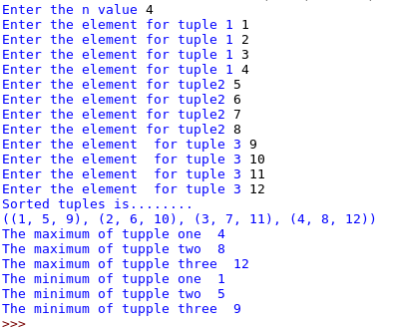

Result

Thus To Develop a python program to add 2 values into an existing tuple named as tuple_1 which has 2 elements. has been successfully developed and the output was verified.

Ex no: 10 | Tuple Operations On Python Programming
Date : | Tuple Operations On Python Programming

Question
1. In a school a teacher has to create a list of students and their class subjects. Each staff is given
only one class so that the list of students and subjects will not change (no modification and
deletion).
OPERATION TO BE PERFORMED
1.Create two tuples named student_name_tup and subject_tup.
2.Create a nested tuple with name and their roll number.
3.Teacher needs to know how many students name start with “a”.
4.Find the number of students in student_name_tup.
5.Check whether Maths subject is available in subject_tup.
6.Concatenate both tuples and print it.
7.The teacher has to display the each student’s name along with their subjects they are studying.

Aim
To In a school a teacher has to create a list of students and their class subjects. Each staff is given
only one class so that the list of students and subjects will not change
Algorithm
Step1.Get n value
Step 2. Set for loop until range n
Step 3. Get name,sub,rool:no then append it on different list
Step 4. Set for loop until range n
Step 5. Check if lsit[i][0]==’a’
Step 6.Print list[i][0]
Step 7. set c=len(list1)
Step 8. print(c)
Step9 Set for loop until range n
Step 10. Check if list2[i]==’maths’ increase c
Step 11. print c
Step 12. set x=map the list by map()
Step 13. print list(x)

Code
name=()
sub=()
list1=[ ]
sub=0
list2=[]
roll=0
lastlist=[]
list3=[]
c=0
count=0
abc=[]
tu=tuple()
n=eval(input("Enter the n value "))
for i in range(n):
nam=input("Enter the students name ")
sub=input("Enter the subject ")
list1.append(nam)
list2.append(sub)
for i in range (n):
roll=eval(input('Enter the roll nos '))
list3.append(roll)
lastlist=[ roll,list1 ]
tu=tuple()
for i in range (n):
if(list1[i][0]=='a'):
print(' ')
print("The name start with a is...",list1[i])
c=len(list1)
print( )
print("The number of students in student_name_tup ",c)
print()
for i in range (n):
if(list2[i]=="maths"):
print('Maths subject is available ')
count+=1
print(count)
print("Now display the each student’s name along with their subjects they are studying")
print(' ')
zip(list1,list2)
tu=tuple(zip(list1,list2))
print(tu)

Output

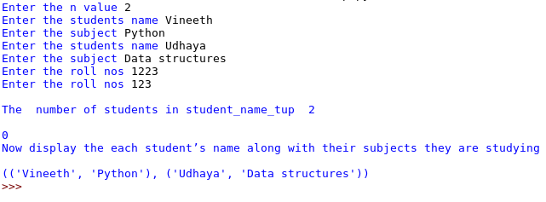

Result
Thus To In a school a teacher has to create a list of students and their class subjects. Each staff is given only one class so that the list of students and subjects will not change has been successfully developed and the output was verified.

Ex no: 11 | Tuple Operations On Python Programming
Date : | Tuple Operations On Python Programming

Question
There are ‘N’ number of integers in a list .There are 2 disjoint sets, A and B , each containing
‘M’ integers. You like all the integers in set A and dislike all the integers in set B. Your initial
happiness is Zero. For each integer ‘i’ in the list, if i € A , you add 1 to your happiness. If i € B,
you lose -1 to your happiness. Otherwise, your happiness does not change. Output your final
happiness.

Aim
To Develop a python code to find the final happiness

Algorithm
Step1.Set a and b is a sets
Step 2.Get the value x
Step 3. Set the for loop range x
Step 4.Get the value y
Step 5. Append the value in N
Step 6.Set the for loop range m
Step 7. Get d value and append it on a
Step 8. Get e value
Step 9.append it on b
Step 10.Check if a.isdisjoint(b)==True
Step 11.Set the for loop range N
Step 12.check if i in a
Step 13.Increase c
Step 14.Otherwise Decrese c
Step 15.Print(c)

Code
N=[]
a=set()
b=set()
c=0
x=eval(input("Enter the value "))
for i in range(x):
y=eval(input("Enter the value to append "))
N.append(y)
m=eval(input("Enter the limits for set a and b "))
for i in range(m):
d=eval(input("Enter the value for set a "))
a.add(d)
e=eval(input("Enter the value for set b "))
b.add(e)
if (a.isdisjoint(b)==True):
for i in N:
if i in a:
c=c+1
else:
c=c-1
print("Final Happiness is :",c)

Output

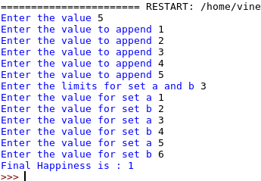

Result
Thus To Develop a python code to find the final happiness has been successfully developed and the output was verified.

Ex no: 12 | Tuple Operations On Python Programming
Date : | Tuple Operations On Python Programming

Question
In a school two teams are formed for the kabadi tournament, each team has to hold the equal
number of boys and their body weight must be selected in equal manner. Help the referee to
do various operations
Operations need to be done:
1. Create two sets named as Team_A and Team_B.
2. Combine both the sets and display the result.
3. Display only the weight of the boys whose value is present in both the teams.
4. Display the weight of the boys in which is present in Team A but not in Team_B.
Operation,Symmetric_Difference_update for both the sets.
5. Display the values in sorted order.

Aim
To Display the student team details using Sets

Algorithm
Step 1.Set two sets
Step 2.Get the value x.
Step 3.Set for loop intil rangr x
Step 4.Get y value
Step 5.Set Teama.add(y)
Step 6.Get the z value
Step 7. Set Teama.add(z)
Step 8.print(Team_a.union(Team_b))
Step 9.print(Team_a.intersection(Team_b))
Step 10.print(Team_a.symmetric_difference_update(Team_b)
Step 11.print(sorted(Team_a))
Step 12.print(sorted(Team_b))
Code
Team_a=set()
li=[]
Team_b=set()
x=eval(input("Enter the value n "))
for i in range(x):
y=int(input("Enter the set value a "))
Team_a.add(y)
z=int(input("Enter the set value b "))
Team_b.add(z)
print("1. Display only the weight of the boys whose value is present in both the teams")
print("2. Display the weight of the boys in which is present in Team A but not in Team_B")
print("3. Display the Symmetric_Difference_update for both the sets")
print("4. Display the Set in sorted order")
d=eval(input("Enter the choice "))
while(d<5 and d>0):
if (d==1):
print(Team_a.union(Team_b))
elif(d==2):
print(Team_a.intersection(Team_b))
elif(d==3):
Team_a.symmetric_difference_update(Team_b)
print(Team_a)
else:
print(sorted(Team_a))
print(sorted(Team_b))
d=eval(input("Enter the choice "))
print("Program exited!!!")

Output

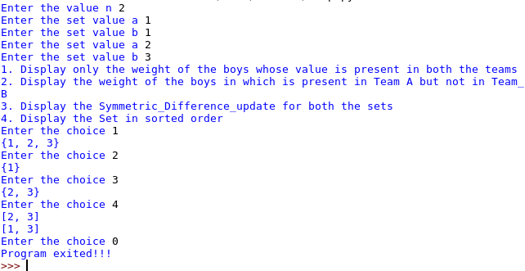

Result
Thus To Display the student team details using Sets has been successfully developed and the output was verified.
Ex no: 13 | Python Programming Using Dictonary
Date : | Python Programming Using Dictonary

Question
Write a python program to fetch 10 review comments from the user. Create a dictionary with
five positive and negative words assigned with 'pos' and 'neg' value. Check whether the comment
includes the word in dictionary. If the word is assigned with positive value, increase the count
by 1 and if the word is assigned with negative value then the polarity count decrease by one.
Finally display the overall polarity score.

Aim
To Find polarity by words

Algorithm
Step1.Declare dict1={'great1':'pos','brilliant':'pos','low':'neg','worthy':'pos','protective':'pos','fantastic':'pos','great':'pos','poor':'neg','high':'neg'}
Step 2.Get the n value
Step 3. Set the for loop until range x
Step 4. Get m value
Step 5. Set z=split(“ “)
Step 6.Set for loop until dict1.keys()
Step 7.Check if dict1[1]==’pos’
Step 8. Increase the count
Step 9.Otherwise Decrease the count
Step 10. print(c)

Code
dict1={'great1':'pos','brilliant':'pos','low':'neg','worthy':'pos','protective':'pos','fantastic':'pos','great':'pos','poor':'neg','high':'neg'}
n=eval(input("Enter the n value "))
count=0
c=0
for i in range (n):
m=input("Enter the string value ")
z=m.split(" ")
for i in z:
if i in dict1.keys():
if dict1[i] =='pos':
c+=1
if dict1[i]=='neg':
c-=1
print("Final polarity is ....",c)

Output

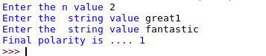

Result

Thus To Find polarity by words has been successfully developed and the output was verified.

Ex no: 14 | Python Programming Using Dictonary
Date : | Python Programming Using Dictonary

Question
Create a nested dictionary for the following five countries with proper key, value pairs namely
capital, currency, country and ISO codes.
As Mr. Ramkumar decided to undergo International Trade to improve his profit, he would like to
refer to various countries and their telecommunication details.
1.Find the currency of Japan.
2.Display the capital of China.
3.Display all the details of India.
4.Determine the ISO and Country codes of America.
5.Display all the details of the country where the Country code is equal to 1.

Aim
To Develop a python program to solve the following operations with the information given above.

Algorithm
Step1.Declare d1={'India':{'capital':'delhi','currency':'Rupees','country code':91,'ISO code':'IN'},'America':{'capital':'washington','currency':'Dollar','country code':684,'ISO code':'AS or ASN'},'China':{'capital':'Beijing','currency':'Ren','country code':86,'ISO code':'CN'},'Canada':{'capital':'Ottawa','currency':'Canadian dollar','country code':1,'ISO code':'CAN'},'Japan':{'capital':'Tokyo','currency':'Yen','country code':81,'ISO code':'JP'}}
Step 2. Get n value
Step 3. Check if n==1
Step 4.Get the value x
Step 5. print(d1[x]['currency'])
Step 6.Check if n==2
Step 7.Get x value
Step 8. print("Details of ",x, "is",d1[x])
Step 9. Check if n==3
Step 3.Get the value x
Step 4.print("Details of ",x, "is",d1[x])
Step 5. Check If n==4
Step 6.Get the value x
Step 7.print("The ISO and Country Codes of ",x, "is.......")
Step 8.print(d1[x]['country code'])
Step 9.print(d1[x]['ISO code'])
Step 10. print("Details of ",x, "is",d1[x])
Step 11:Check if n==5
Step 10. print("To display the country with country code is 1")
Set for i in d1:
Cheack if (d1[i]['country code']==1):
print(d1[i])

Code
d1={'India':{'capital':'delhi','currency':'Rupees','country code':91,'ISO code':'IN'},'America':{'capital':'washington','currency':'Dollar','country code':684,'ISO code':'AS or ASN'},'China':{'capital':'Beijing','currency':'Ren','country code':86,'ISO code':'CN'},'Canada':{'capital':'Ottawa','currency':'Canadian dollar','country code':1,'ISO code':'CAN'},'Japan':{'capital':'Tokyo','currency':'Yen','country code':81,'ISO code':'JP'}}
print("case 1 for To find currency")
print("Case 2 for to find capital")
print('Case 3 for find details of country')
print("case 4 for display iso codes n country codes")
print("Case 5 for for display the country code==1 ")
while True:
n=eval(input("Enter the case "))
if(n==1):
x=input("enter the country to find its currency....")
print(d1[x]['currency'])
elif(n==2):
x=input("Enter the country to find capital....")
print(d1[x]['capital'])
elif(n==3):
x=input("Enter the country to find the details.......")
print("Details of ",x, "is",d1[x])
elif(n==4):
x=input("Enter the country to display its iso codes...")
print("The ISO and Country Codes of ",x, "is.......")
print(d1[x]['country code'])
print(d1[x]['ISO code'])
elif(n==5):
print("To display the country with country code is 1")
for i in d1:
if (d1[i]['country code']==1):
print(d1[i])
else:
print("Program terminated!!!")
break

Output
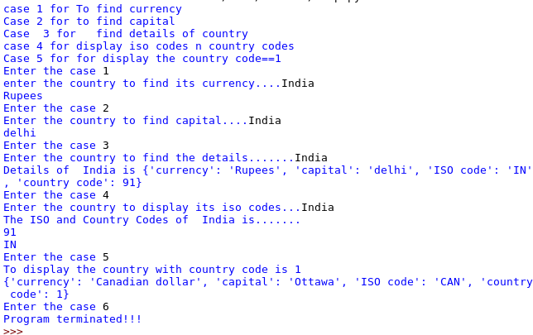

Result
Thus To Develop a python program to solve the following operations with the information given above. has been successfully developed and the output was verified.
Ex no: 15 | Implement using Functions
Date : | Implement using Functions

Question
Write a Python Required argument function named as allDigitsOdd that returns whether
every digit of a positive integer is odd. Your function should return true if the number consists
entirely of odd digits and false if any of its digits are even. 0, 2, 4, 6, and 8 are even digits, and
1, 3, 5, 7, 9 are odd digits.
For example, allDigitsOdd(135319) returns true but allDigitsOdd(9145293) returns false.

Aim
To Write a Python program Find polarity by words

Algorithm
Step1.Declare the funvtion alldigitodd(n)
Step 2..Set the loop until n
Step 3. Check if(int (i)!=1)
Step 4. return False
Step 5 Break
Step 6.Otherwise Return False
Step 7. Print(allDigitsOdd(input("enter digit :")))

Code
def allDigitsOdd(n):
for i in n:
if int(i)%2 != 1:
return "false"
break
else:return "true"
print(allDigitsOdd(input("enter digit :")))

Output

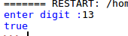

Result
Thus To Write a Python program Find polarity by words has been successfully developed and the output was verified.

Ex no: 16 | Implement using Functions
Date : | Implement using Functions

Question
Write a Python default argument function named season that takes two integers as parameters
representing a month and day and that returns a String indicating the season for that month and
day. Assume that months are specified as an integer between 1 and 12 (1 for January, 2 for
February, and so on) and that the day of the month is a number between 1 and 31.

Aim
To Write a Python default argument function named season that takes two integers as parameters
representing a month and day and that returns a String indicating the season for that month and
day.

Algorithm
Step 1.Declare a function(month,date)
Step 2. if the month and date suite for winter
Step 3. print ‘winter’
Step 4.if the month and date suite for spring
Step 5. print ‘spring’
Step 6.if the month and date suite for summer
Step 7. print ‘summer’
Step 8.if the month and date suite for fall
Step 9. print ‘fall’
Step 10.Otherwise print ‘Invalid date’

Code
def season(mon=1,date=1):
if (mon==12 and date>=16)or(mon<3)or(mon==3 and date<=15):
return "winter"
elif (mon==3 and date>=16)or(mon>3 and mon<6)or(mon==9 and date<=15):
return "Spring"
elif (mon==6 and date>=16)or(mon>6 and mon<9)or(mon==9 and date<=15):
return "Summer"
elif (mon==9 and date>=16)or(mon>9 and mon<12)or(mon==12 and date<=15):
return "Fall"
val=input("Enter date : ").split("/")
mon=int(val[0])
date=int(val[1])
if mon>=1 and mon<=12 and date>=1 and date<=31:
print(season(mon,date))
else:
print("Invalid date")

Output

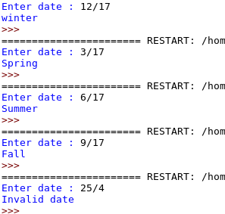

Result
Thus To Write a Python default argument function named season that takes two integers as parameters representing a month and day and that returns a String indicating the season for that month and day has been successfully developed and the output was verified.
Ex no: 17 | Built-in Exception Handling in Python Programming
Date : | Built-in Exception Handling in Python Programming

Question
Write a python function which accepts variable length arguments and to remove duplicate
numbers and return a unique set of elements. But, the output order should be same as input
order. Make sure that your function should allow only integer type Values. A function should
return unique elements only when all the arguments are integer, else throw an exception
called NonIntegerError.

Aim
To Write a python function which accepts variable length arguments and to remove duplicate
numbers and return a unique set of elements.

Algorithm
Step 1.Declare the class variable()
Step 2. Declare the function called pt(self)
Step 3. print( a string )
Step 4. Declare a function
Step 5.TRY:
Step6.Set for loop until range arg:
Step 7 Check if i.isdigit() and int(i) not in li
Step 8Append it on list one
Step 9. Otherwise Raise error
Step 10. Set except Exception as e
Step 11.Call function
Step 12. Set for loop range until user input
Step 13.Append it on listtwo
Step 14.Call the function by listtwo

Code
class NonIntegerError(Exception):
def pt(self):
print("You entered a Non Integer value ")
li=[]
def fun(*arg):
try:
for i in arg:
if i.isdigit():
if int(i) not in li:
li.append(int(i))
else:
raise NonIntegerError
print(li)
except NonIntegerError as e:
e.pt()

l1=[]
for i in range(int(input('Enter the number of values '))):
l1.append(input("Enter the value "))
fun(*l1)

Output

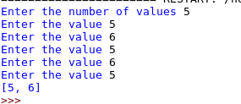

Result

Thus To Write a python function which accepts variable length arguments and to remove duplicate
numbers and return a unique set of elements. has been successfully developed and the output was verified.

Ex no: 18 | Built-in Exception Handling in Pyton Programming
Date : | Built-in Exception Handling in Pyton Programming

Question
Develop a python program to display the Previous Greatest Element (PGE) for every element entered by
the user until the limit. To find the Previous greatest Element compare it with the next element. Elements
for which no greater element exist, consider next greater element as -1.

Aim
To Consider in a Ticket booking system, initially count of ticket will be 60, when
the customer books the ticket , ticket count should be reduced and stored in dictionary.

Algorithm
Step1.Declare the class variable()
Step1.1 Declare the function called pt(self)
step1.1.1 print( a string )
Step 2. Declare a function
Step 3.TRY:
Step 4.Get the value n
Step 3.Get the value gt
Step 4. Check if ti-gt >0
Step 5.d1={n:gt}
Step 6.di.update(di)
Step 7.Otherwise Raise error call
Step 8.Set Except exception a e
Step 9.Call e.pt()
Step 10.Otherwise TRY:
Step 11.Print(all details)

Code
class TicketNotAvailable(Exception):
def pt(self,i):
print('TicketNotAvailable,sorry ticket available is ',i)
ch=int(input('Enter your choice '))
ti=60
di={}
while(ch>0 and ch<3):
if ch==1:
try:
n=input('Enter the name ')
gt=int(input('Enter the no of tickets '))
if ti-gt >=0:
d1={n:gt}
di.update(d1)
ti-=gt
else:
raise TicketNotAvailable
except TicketNotAvailable as e:
e.pt(ti)
elif(ch==2):
try:
n=input("Enter the name ")
print('The no of tickets got by {} is'.format(n),di[n])
except Exception:
print('No name is there ')
ch=int(input('Enter your choice '))
print('The remaining tickets is ',ti)

Output
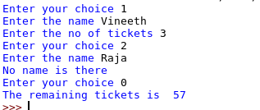

Result
Thus To Consider in a Ticket booking system, initially count of ticket will be 60, when
the customer books the ticket , ticket count should be reduced and stored in dictionary has been successfully developed and the output was verified.

Ex no: 19 | User Define Exception Handling in Python Programming
Date : | User Define Exception Handling in Python Programming

Question
Ram is assigned a task by the Coimbatore corporation to check the persons who are
medically fit for the persons who are staying in the refugees camp. He must check all
the constrains which are listed below.
1. Weight must be greater than 45.
2. Must not have any eye problem (Myopia/Hypermetropia)
3.Must not have any Communicable Diseases.
Once all the conditions are satisfied, ram is allowed to provide the medically fit
certificate,else create a user defined exceptions as MedicallyUnfitexception which
display the error message as “UNFIT”

Aim
To Construct aPython program to Medcical check

Algorithm
Step1.Declare the class variable()
Step 2. Declare the function called pt(self)
Step 3. print( a string )
Step 4. Set A for loop until range from user input
Step 5.Declare a list contain No ,NO,no,nO
Step 6.Get the name
Step 7.Get the weight
Step 8.Get the vision and commnuicable
Step 9.TRY:
Step 10.IF (weight <=45 or vision not in li or communicable not in li)
Step 11.RAISE USERERROR
Step 12.Otherwise print('MEDICAL CERTIFICATE PROVIDED')
Step 13.Set except MedicallyUnfit as c
Step 14. c.put()

Code
class MedicallyUnfit(Exception):
def put(self):
print('MedicallyUnfitException')
for i in range(int(input('ENTER THE NO OF PERSONS '))):
li=['NO','no','No','nO']
name=input('ENTER THE NAME ')
weight=int(input('ENTER THE WEIGHT '))
vision=input('HAVING VISION PROBLEM OR NOT ')
communicable=input('HAVING ANY COMMUNICABLE DISEASES OR NOT ')
try:
if weight <= 45 or vision not in li or communicable not in li :
raise MedicallyUnfit
else:
print('MEDICAL CERTIFICATE PROVIDED')
except MedicallyUnfit as c:
c.put()

Output

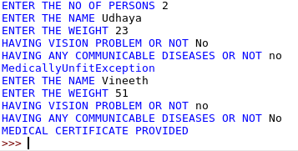

Result
Thus To Construct aPython program to Medcical check has been successfully developed and the output was verified.

Ex no: 20 | User Define Exception Handling in Python Programming
Date : | User Define Exception Handling in Python Programming

Question
Consider a banking scenario, Should perform deposit and withdraw operations.
Minimum balance should be 500. If the balance is below 500, should arise
InSufficientBalanceexception. If the withdraw amount is greater the deposited
amount arise an exception, InsufficientFundsException. If there is no exception
raised Display the total balance of the user.

Aim
To Write a python program to Done a Bank operations

Algorithm
Step 1.Declare the class variable()
Step 2 .Declare the function called pu(self)
Step 3. print( a string )
Step 4.Declare the class variable()
Step 5. Declare the function called pt(self)
Step 6. print( a string )
Step 7. Get balance
Step 8.TRY:
Step 9.Check if val-wi<0
Step 10.Raise usererror
Step 11.Otherwise check if bal<500
Step 12.Raise usererror2
Step 13.Check if bal<500
Step 14.Raise usererror
Step 15.print(BALANCE)
Step 16.Set except MedicallyUnfit as c,e
Step 17.e.pu() c.pu()

Code
class InSufficientFund(Exception):
def pu(self):
print('InSufficientFund')
class InSufficientBalance(Exception):
def pt(self):
print('InSufficientBalance')
bal=int(input('ENTER THE AMOUNT TO BE DEPOSITED '))
try:
if bal<500:
raise InSufficientBalance
wi=int(input('ENTER THE AMOUNT TO BE WITHDRAWED '))
if bal-wi < 0:
raise InSufficientFund
else:
bal-=wi
if bal<500:
raise InSufficientBalance
if bal<500:
raise InSufficientBalance
print('BALANCE AMOUNT IS',bal)
except InSufficientBalance as e:
e.pt()
except InSufficientFund as e:
e.pu()

Output

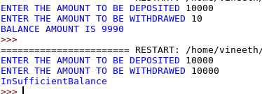

Result
Thus To Write a python program to Done a Bank operations ber has been successfully developed and the output was verified.

Ex no: 21 | Classes and Objects
Date : | Classes and Objects

Question
Implement the UML Class diagram using Python programming.

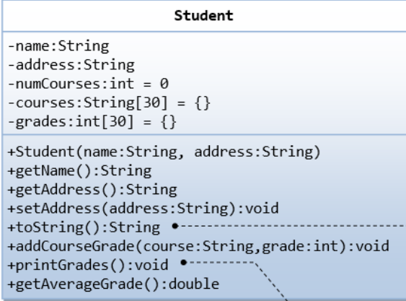

Aim
To Implement the UML Class diagram using Python programming.

Algorithm
Step1.Create a class Student:
Step2.Decalre the course and grade as private varible
Step 3. Declare a function (initative)
Step 4.Declare the name ,address as private varible
Step 5.Set the name,address to memory by set function
Step 6.In getadd function return the value
Step 7.By using __repr__ function return all details
Step 8.Find average and return it
Step 9.Create a memiry for class by object
Step 10.Call all the function
Step 11.print(object)

Code
class Student():
__course=set()
__grade={}
def __init__(self,name,address):
self.__name=name
self.__address=address
def setAddress(self,addr):
self.__address=addr
def addcoursegrade(self,course,grade):
self.__course.add(course)
self.__grade.update({course:grade})
def getName(self):
return self.__name
def getAddress(self):
return self.__address
def printgrade(self):
for i in self.__grade.items():
print(i)
def getavggrade(self):
return (sum(self.__grade.values())/len(self.__grade.values()))
def __repr__(self):
return (self.getName(),self.getAddress())
obj=Student(input("Enter the name "),input("Enter the address "))
obj.setAddress(input("Enter the address to overwrite "))
for i in range(int(input("Enter the no of courses "))):
obj.addcoursegrade(input("Enter the courses " ),int(input("Enter the grade ")))
obj.printgrade()
print(obj.getavggrade())
l=obj.__repr__()
print("Name {}\n Address {}".format(l[0],l[1]))

Output

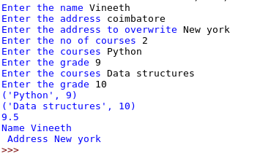

Result
Thus To Implement the UML Class diagram using Python programming. has been successfully developed and the output was verified.
Ex no: 22 | Classes and Objects
Date : | Classes and Objects

Question
Implement the UML Class diagram using Python programming.

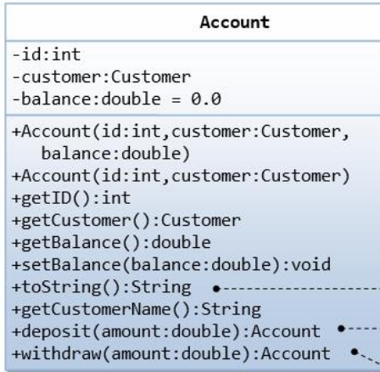

Aim
To Implement the UML Class diagram using Python programming.
Algorithm
Step 1.Create a class Account:
Step 2. Declare a function (initative)
Step 3.Declare the id ,customer ,balanceas private varible
Step 4.Get the name,address to memory by set function
Step 5.Return customer,id,balance+x
Step 6.In withdraw function and deposit function
Step 7.Set balance-y and balance+x
Step 8.By using __repr__ function return all details
Step 9.Create a memory for classs by object
Step 10.Call all the function
Step 11.print(object)

Code
class Account():
def __init__(self,id,cust,bal):
self.__id=id
self.__cust=cust
self.__bal=bal
def getcustomername(self):
return self.__cust
def getbalance(self):
return self.__bal
def getid(self):
return self.__id
def deposit(self,x):
self.__bal=self.__bal+x
def withdraw(self,y):
self.__bal=self.__bal-y
def __repr__(self):
return (" ID is {} \n Customer Name is {}\n Balance is {}".format(self.getid(),self.getcustomername(),self.getbalance()))
obj=Account(int(input("Enter the id ")),input("Enter the customer name "),float(input("Enter the balance ")))
obj.deposit(float(input("Enter the amount to be deposited ")))
obj.withdraw(float(input("Enter the amount to be withdrawed ")))
print(obj.__repr__())

Output
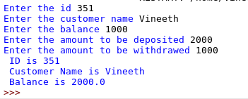

Result
Thus To Implement the UML Class diagram using Python programming. has been successfully developed and the output was verified.
Ex no: 23 | Inheritance,Abstraction and Polymrphism
Date : | Inheritance,Abstraction and Polymrphism

Question
Identify the relationship among classes and develop a Python program to illustrate the identified
Relationship

Aim
To Identify the relationship among classes and develop a Python program to illustrate the identified
Relationship

Algorithm
Step 1.Create a class Person:
Step 2. Declare a function (initative)
Step 3.Declare the name ,address private varible
Step 4.Set sget the name and address and return it
Step 5.using __repr__ function return all the value
Step 6.Create a another class(Person):
Step 7.Decalre a function and set name,address,program,year,fee as private varible
Step 8.Using get set function set all value
Step 9.Return to person calss using super() function
Step 10.Create a another class nStaff(Person):
Step 11.Declare the name ,address,scl,pay private varible
Step 12.Using get set function set all value
Step 13.Return to person calss using __repr__ function
Step 14.Create a memory for student and staff
Step 15.Call all the function
Step 16.print(obj1.__repr__())
Step 17.print(obj2.__repr__())

Code
class Person:
def __init__(self,name,addr):
self.__name=name
self.__addr=addr
def setAddress(self,adds):
self.__addr=adds
def getName(self):
return self.__name
def getAddress(self):
return self.__addr
def __repr__(self):
return "Name : {}\nAdress : {}\n".format(self.getName(),self.getAddress())
class Student(Person):
def __init__(self,name,addr,prog,year,fee):
super().__init__(name,addr)
self.__prog=prog
self.__year=year
self.__fee=fee
def setProgram(self,pro):
self.__prog=pro
def getProgram(self):
return self.__prog
def setYear(self,yea):
self.__year=yea
def getYear(self):
return self.__year
def setFee(self,fe):
self.__fee=fe
def getFee(self):
return self.__fee
def __repr__(self):
return super().__repr__()+"Program : {}\nYear :{}\nFee : {}\n".format(self.getProgram(),self.getYear(),self.getFee())
class Staff(Person):
def __init__(self,name,addr,scl,pay):
super().__init__(name, addr)
self.__schl=scl
self.__pay=pay
def setSchool(self,sc):
self.__schl=sc
def getSchool(self):
return self.__schl
def setPay(self,p):
self.__pay=p
def getPay(self):
return self.__pay
def __repr__(self):
return super().__repr__()+"School : {}\nPay : {}".format(self.getSchool(),self.getPay())
obj1=Student(input("Enter student name "),input("Enter student address "),input("Enter student program "),int(input("Enter year ")),float(input("Enter fees ")))
obj1.setProgram(input("Enter the program to overwrite "))
obj1.setYear(int(input("Enter year to overwrite ")))
obj1.setFee(float(input("Enter fee to overwrite ")))
print(obj1.__repr__())
obj2=Staff(input("Enter staff name "),input("Enter the staff address "),input("Enter the school "),float(input("Enter the payment")))
obj2.setSchool(input("Enter the school to overwrite "))
obj2.setPay(float(input("Enter the payment to overwrite ")))
print(obj2.__repr__())

Output

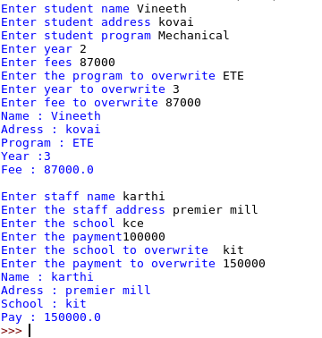

Result
Thus To Identify the relationship among classes and develop a Python program to illustrate the identified Relationship has been successfully developed and the output was verified.
Ex no: 24 | Inheritance,Abstraction and Polymrphism
Date : | Inheritance,Abstraction and Polymrphism

Question
Identify the relationship among classes and develop a Python program to illustrate the identified
relationship.
Aim
To Identify the relationship among classes and develop a Python program to illustrate the identified
Algorithm
Step 1.Create a class Shape:
Step 2. Declare a function (initative)
Step 3.Declare the colour ,fill private varible
Step 4.Set sget the colour and fill and return it
Step 5.using __repr__ function return all the value
Step 6.Create a another class(Shape):
Step 7.Decalre a function and set colour andd fill
Step 8.Using get set function set all value
Step 9.Return to person calss using __repr__ function
Step 10.Create a another class nStaff(Shape):
Step 11.Declare the wid,len,col,fil
Step 12.Using get set function set all value
Step 13.And find perimeter of circle and rectangle
Step 14.Return to person calss using __repr__ function
Step 15.Create a memory for student and staff
Step 16.Call all the function
Step 17.print(obj1.__repr__())
Step 18.print(obj2.__repr__())

Code
class Shape:
def __init__(self,col,fill):
self._col=col
self._fill=fill
def setColour(self,col):
self._col=col
def getColour(self):
return self._col
def setFilled(self,fi):
self._fill=fi
def isFilled(self):
return self._fill
class Circle(Shape):
def __init__(self,rad,col,fill):
super().__init__(col,fill)
self._rad=rad
def setRadius(self,rad):
self._rad=rad
def getRadius(self):
return self._rad
def getArea(self):
return 3.14*self._rad*self._rad
def getPerimeter(self):
return 2*3.14*self._rad
def __repr__(self):
return "Colour : {}\nFilled : {}\nRadius : {}\nArea : {}\nPerimeter : {}\n".format(super().getColour(),super().isFilled(),self.getRadius(),self.getArea(),self.getPerimeter())
class Rectangle(Shape):
def __init__(self,wid,len,col,fil):
super().__init__(col, fil)
self._width=wid
self._length=len
def setWidth(self,wi):
self._width=wi
def getWidth(self):
return self._width
def setLength(self,le):
self._length=le
def getLength(self):
return self._length
def getArea(self):
return self._length*self._width
def getPerimeter(self):
return 2*(self._length+self._width)
def __repr__(self):
return "Colour : {}\nFill : {}\nWidth : {}\nLength : {}\nArea : {}\nPerimeter : {}\n".format(super().getColour(),super().isFilled(),self._width,self._length,self.getArea(),self.getPerimeter())
class Square(Rectangle):
def __init__(self,side,col,fil):
super().__init__(side, side, col, fil)
def __repr__(self):
return super().__repr__()
obj1=Square(float(input("Enter the size ")),input("Enter the colour "),bool(int(input("Enter filled or not "))))
print(obj1.__repr__())
obj2=Circle(float(input("Enter the radius ")),input("Enter the colour "),bool(int(input("Enter filled or not"))))
print(obj2.__repr__())

Output

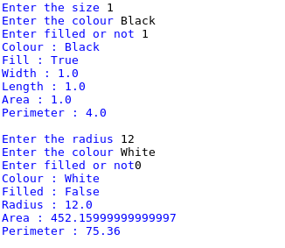

Result
Thus To Identify the relationship among classes and develop a Python program to illustrate the identified Relationship has been successfully developed and the output was verified.
Ex no: 25 | Association, Aggregation and Composition
Date : | Association, Aggregation and Composition

Question
Identify the relationship among classes and develop a Python program to illustrate the identified
relationship using Association, Aggregation and Composition

Aim
To Identify the relationship among classes and develop a Python program to illustrate the identified
relationship using Association, Aggregation and Composition

Algorithm
Step 1.Create a class Department:
Step 2. Declare a function (initative)
Step 3.Declare the name,Dept chair as private varible
Step 4.Set sget the colour and fill and return it
Step 5.using __repr__ function return all the value
Step 6.Create a another Course(Department):
Step 7.Decalre a function init()
Step 8.Get additional course and address
Step 9.Using __repr__ function return all the value
Step 10.Check if(__name__=="__main__"):
Step 11.Create a memory for class and call all the function
Step 12.print(obj1.__repr__())

Code
class Department:
def __init__(self):
self.__dename=input("Enter the department name ")
self.__dechair=input("Enter the department chair ")
def adddepartment(self):
self.adde=input("Enter the additional department ")
def viewdepartment(self):
return self.__dename
def __repr__(self):
return "Department name : {}\nDepartment chair : {}\nAdditional department :{}\n".format(self.__dename,self.__dechair,self.adde)
class Course(Department):
def __init__(self):
super().__init__()
super().adddepartment()
self.__cno=int(input("Enter the course number "))
self.__codes=input("Enter the course description ")
self.__noc=int(input("Enter the no of credits "))
self.__depno=int(input("Enter the department no "))
def addCourse(self):
self.addc=input("Enter the additional course ")
def changeCourse(self):
self.addc=input("Enter the course to be changed ")
def findCourse(self):
return self.addc
def __repr__(self):
return super().__repr__()+"Course no : {}\nCourse description : {}\nNo of credits : {}\nDepartment no : {}\nAdditional course : {}".format(self.__cno,self.__codes,self.__noc,self.__depno,self.findCourse())
if(__name__=="__main__"):
obj1=Course()
obj1.addCourse()
obj1.changeCourse()
print(obj1.__repr__())

Output

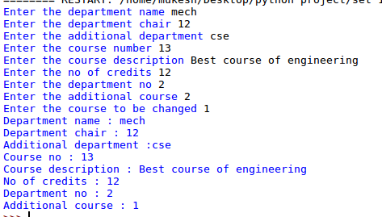

Result
Thus To Identify the relationship among classes and develop a Python program to illustrate the identifiedRelationship has been successfully developed and the output was verified

Ex no: 26 | Association, Aggregation and Composition
Date : | Association, Aggregation and Composition

Question
Identify the relationship among classes and develop a Python program to illustrate the identified
relationship using Association, Aggregation and Composition

Aim
To Identify the relationship among classes and develop a Python program to illustrate the identified
relationship using Association, Aggregation and Composition

Algorithm
Step 1.Create a class Customer:
Step 2. Declare a function (initative)
Step 3.Declare the name,address , cred,shipping,email as private varible
Step 4.Set get the name,address , cred,shipping,email and return it
Step 5.using __repr__ function return all the value
Step 6.Create a function login get email
Step 7.crteate a function updateprofile get name ,add,cred
Step 8.Create a another classs order(Customer)
Step 9.Decalre a function init
Step 10.call super() get all input
Step 11.Create a function placeorder()
Step 12.Get all details by the user
Step 13.Using __repr__ function to return all the value
Step 14.Create a memory for order()
Step 15.Call all the function
Step 16.print(obj1.__repr__())
Step 17.print(obj2.__repr__())

Code
class Customer():
def register(self,name,addr,cred,ship,email):
self.__name=name
self.__addr=addr
self.__cred=cred
self.__ship=ship
self.__email=email
def login(self,email):
if(self.__email==email):
print("Logged in \n")
return 1
else:
print("Invalid login \n")
return 0
def getName(self):
return self.__name
def getAddr(self):
return self.__addr
def updateprofile(self):
self.__name=input("Enter the name to overwrite ")
self.__addr=input("Enter the address to overwrite ")
self.__cred=input("Enter the credit card number to overwrite ")
class Orders(Customer):
def __init__(self):
super().register(input("Enter name"),input("Enter address"),input("Enter credit card number"),input("Enter the shipping info"), input("Enter email id"))
if(super().login(input("Enter the email id"))):
super().updateprofile()
self.k=1
else:
self.k=0
def placeorder(self):
self.__orderid=int(input("Enter the order id "))
self.__dacre=input("Enter the created date")
self.__dashi=input("Enter the date shipped ")
self.__name=super().getName()
self.__custid=input("Enter the customer id ")
self.__status=input("Enter the status ")
self.__shipid=input("Enter the shipping id ")
def __repr__(self):
return "Name : {}\nAddress : {}\nOrder id : {}\nShipped on : {}\n".format(self.__name,super().getAddr(),self.__orderid,self.__dashi)
obj=Orders()
if(obj.k):
obj.placeorder()
print(obj.__repr__())

Output

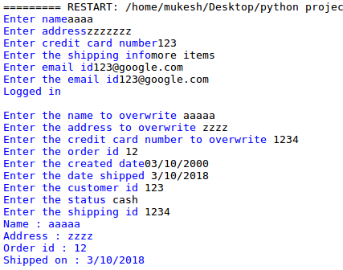

Result
Thus To Identify the relationship among classes and develop a Python program to illustrate the identified relationship using Association, Aggregation and Composition has been successfully developed and the output was verified.

